Jenkins assignment 6 using pipeline
Copy github project and build that project like mvn clean install and push to webapps deploy folder
Step 1 – lauch instance then install java, git , then create 2 directory inside mnt like build-tool and server set up mvn inside build tool set environment and then goto server and set up tomcat give permission to tomcat then goto bin and do ./startup.sh then goto webapp and wget Jenkins and do set up
(Must add custom tcp port 8080 in security group)
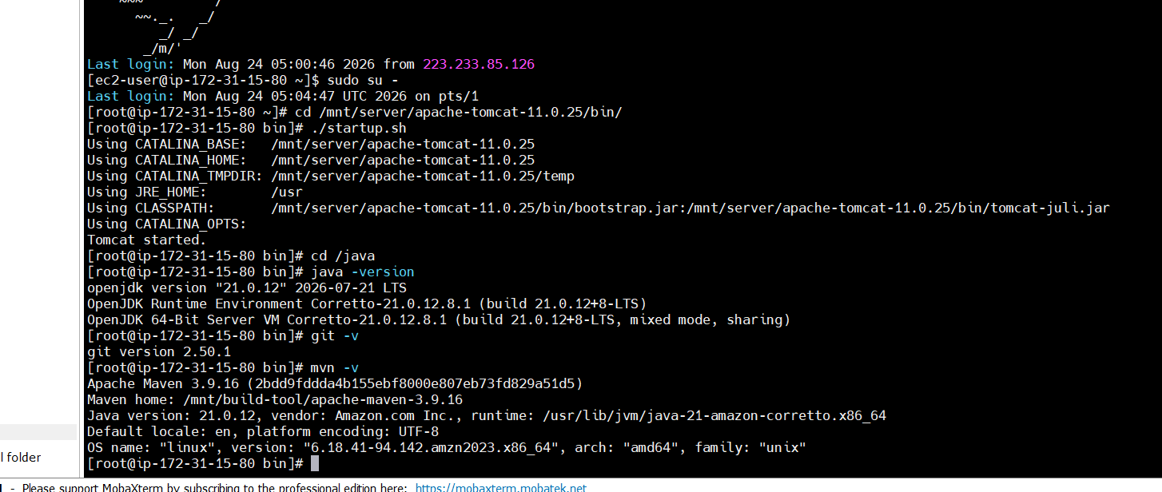
Step 2 – create pipeline and add pipeline code
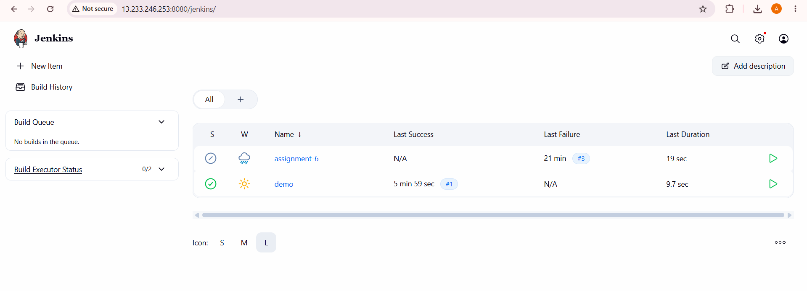
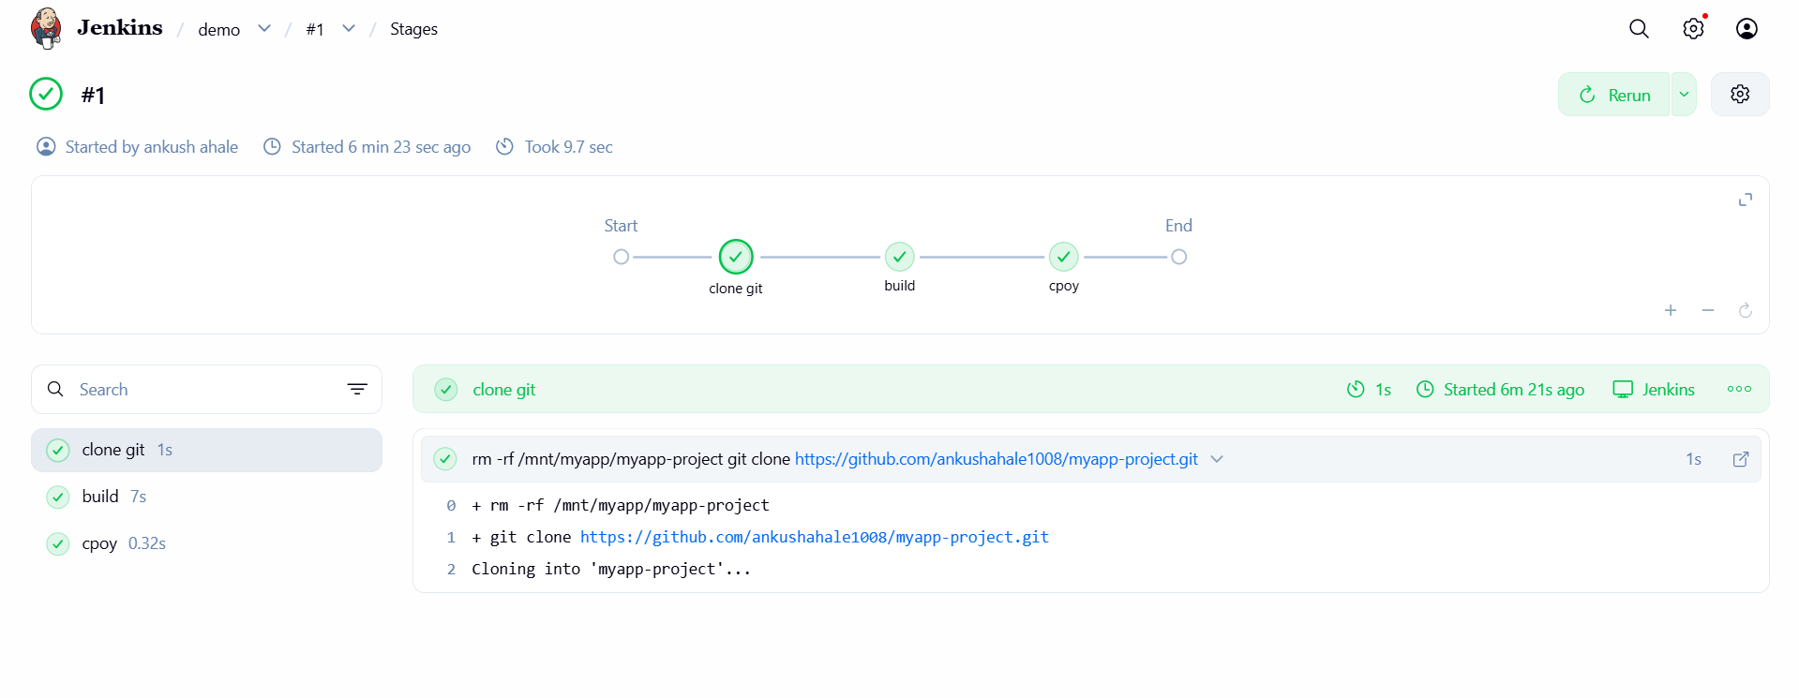
Pipeline code
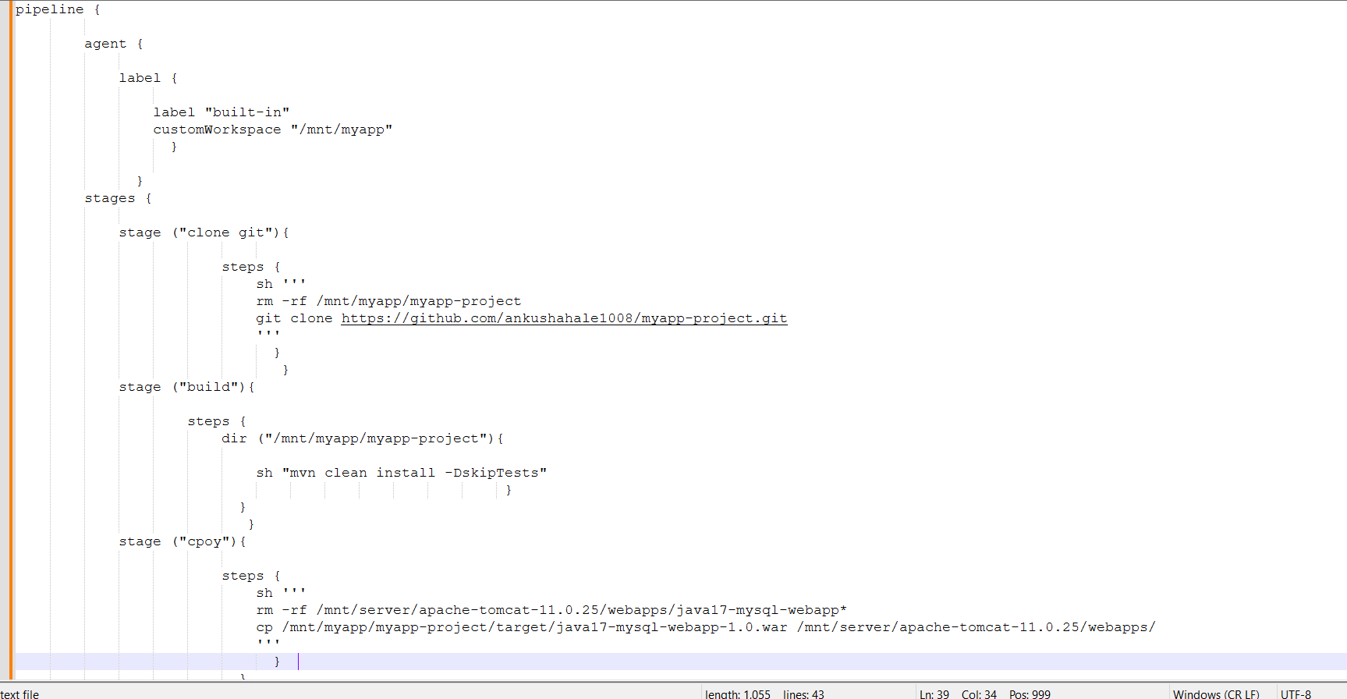
Step 3 – click on apply save then click on build now and check using url like http://ip:8080/projectname
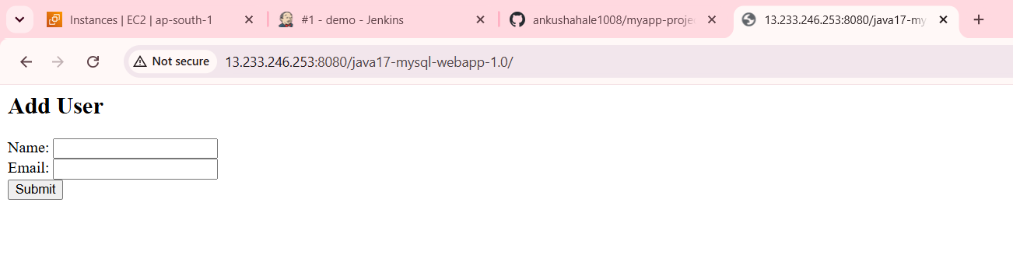
Assignment Done Successfully.

